Technical Story Card

Revision History
Version No. | Date | Prepared by / Modified by | Significant Changes
1 | 14 Jun 2022 | Group 2 | Draft version

MEMBERS- Saurabh Mandal
Nikhil Kumar Pujari
Ameesha Roy
Shachi Shakya
Ayush Kushwaha
Deepak B.

Glossary
Abbreviation | Description
BSC | Business Story Card
TSC | Technical Story Card

Table of Contents
1 Introduction 3
2 Scope of Change 3
3 List of impacted modules 3
4 Design and Detailed technical updates 4
4.1 Process model 4
4.1.1 Use case Model 4
4.2 ER Diagram 5
4.3 Client registration 6
4.4 Log in 7
4.5 Architecture diagram 8
4.6 Sequence diagram 10

Introduction
Edubee, the Web App, is an Exam Preparation System which aims to help students practice and improve their skills at a scholastic level for their exams alongside with helping them with other courses for increasing their skills in basic programming languages and also give all sorts of tests to check their knowledge. The web app holds both Subjective and Programming related contents and Assessments for assessing students and help them achieve their goals.

Edubee is a web app which holds features like providing the students with courses like Physics, Chemistry and Maths and with Programming languages like JavaScript, Html and CSS for levelling up their Programming skills for their future IT studies.

Edubee is a collective Study Web App providing Study materials for students helping them clear their doubts and Assessment for levelling their skills up. Edubee is a web app that holds everything for beginner students to help them improve their knowledge and skills in this competitive era.

Scope of Change
Change will not be entertained and whatever specifications mentioned in this document is final.

List of impacted modules
All the functional modules will be created from scratch.

Design and Detailed technical updates

Process model

Use case Model

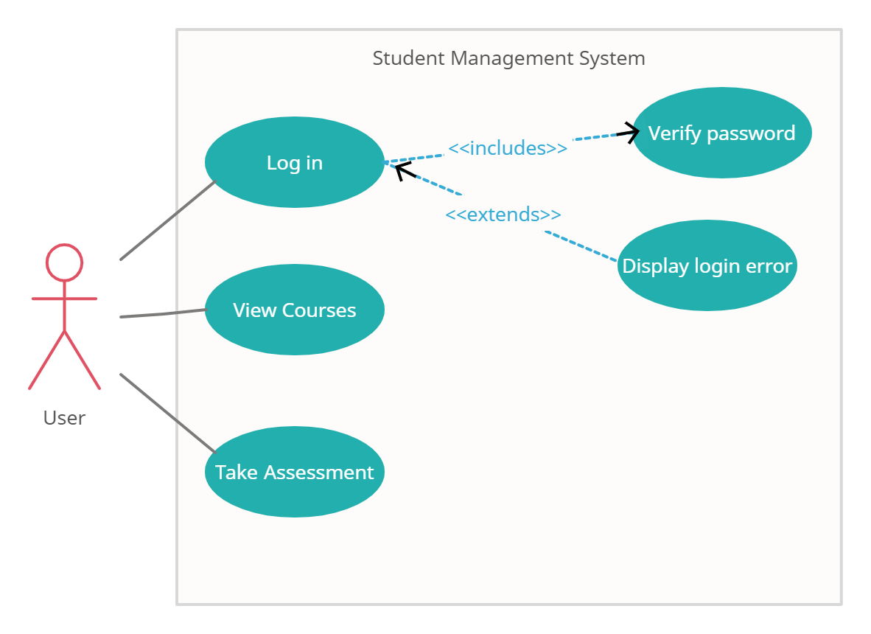

ER Diagram
email

New password
email
Password
Name
email
Dashboard
Login
Forgot Password
password
Mobile
Confirm password
Registration
Log out
Courses
Assessments
Settings
START

Brief Description | Client Registration
Basic Flow | This use case describes how a client register in to the system  - The client has to register himself into the system.  - After the successful registration, client will get a success message.  - The following information is required during registration.  - Name  - Mobile number  - Email  - Password  - Confirm Password
Alternate Flow | - The system will validate the information provided. If any invalid data is found, the input form will be shown an error message.
Validation | - Name is required and max 30 characters.  - Mobile number is required and must have 10 digits.  - The Email is required and should be valid.  - Password is required with minimum 8 character and must contain an uppercase, a lowercase, a special character and a number.  - Password should match with Confirm Password.
Post-Conditions | Success message should be shown.



Brief Description | Login
Basic Flow | This use case describes how a user log-in in to the system  - The client has to register himself into the system.  - After the successful login, user will be taken to the appropriate login page.  - The following information is required to login.  - username  - password
Alternate Flow | - The system will validate the credentials provided. If credentials are invalid, error message will be shown.
Validation | - Username is required.  - Password is required.
Post-Conditions | Success message will be shown and landing page will be displayed.



Architecture diagram

Layer
Logical View
Technology/ Framework

UI Components

Registration
Dashboard
Presentation Layer
HTML/ CSS/ Type Script/ Angular
Courses
Assessment

Settings
Logout

Web-Server Classes
Java 1.8/ Spring Boot
Application/ Business Layer
Properties
Controllers

Service
REST Controllers

Entity/ Model Classes

Data Access Layer
Spring data JPA/ Hibernate ORM
JPA Repository class

Oracle 11g Database

Presentation Layer:
This layer consists of all UI components.
- Registration component: This component helps user to register, login and validate user credentials.
- Dashboard: This is the landing page of the website. It will give an overview of other components.
- Courses component: This will help user to go through and select different courses.
- Assessment component: Using this component user can participate in assessments to test their abilities.
- Settings: This component will help the user to update details in their profile.
- Logout component: User can log out of their current session.

Application Layer:
This layer comprises of all server and business classes.
- Properties: It contains the database credentials such as username and password.
- Spring Controllers defines the server classes, which are required to process the incoming http requests.
- Service classes are required to perform the required business services.
- REST Controllers to process the HTTP AJAX requests.
- Model classes are used the define the functions of the entities present in the system.

Data Layer:
Data layer is implemented through Hibernate ORM. It will contain the repository classes, which provides interface to the table.

Sequence diagram

